**Scope of Work:**

**POC for Dynamics 365 Customer Service, CoPilot out of box implementation and process understanding.**

Background and Requirements:

European Client is looking to deploy D365 customer service platform along with the copilot for language neutralization, enabled only for Teams Chat, the high-level requirements listed by the customer are as follows:

* Chats Language neutralizations
* Self-service: creation of incidents and transfer the incident to Service NOW through automation technologies/interactive chats
* Usage of Generative AI for incidents resolutions (to increase the first call resolutions)
* Telecom Infrastructure for calling: Existing telephone numbers must be ported/connected to Microsoft solutions.
* Interfacing with ServiceNow applications
* Realtime reporting: Calls and chats Realtime dashboard should be made available to SD agents and SD operational manager.to understand the queue and take necessary corrective steps & may be announcement mechanism should be in place in case of known issues to avoid the flooding of calls.
* All transactional records must be stored in a retrievable format for future analysis,
* Application must Facilitate interface between SD agents and Users, as many times following up with users is tedious and most time consuming (this could be automated through automatic/intelligent scheduling based on availability of the users and SD agents etc)
* Similarly chasing of Level 2 team for resolution should be automated to keep up the incidents and its timely closures.

Based on the various discussions held from the workshop done on the 13th of Dec, and subsequent conversations, the following has been drafted as the high-level scope of work in a phased approach.

High Level Scope of Work:

The project shall be approached in 2 phases:

**Phase 1 Discovery:**

With a dedicated functional analyst deployed for BCOE, remotely or on site as the requirement may be, the purpose of this deployment would be:

Conduct a discovery session with respective stake holders to understand the business process that would need to be defined for the deployment of the OOB functions of D365 Omni Channel Customer Service, with copilot services, for enablement of auto translations of all chats in respective local languages.

Understand the integration points for service now, which shall remain the primary platform for the tickets, SLA, responses, and resolution.

Identification of the hierarchical structure that would need to be deployed during the implementation of the platform.

A set of sample questions that would be derived from the discovery phase are listed as follows:

**Business Process:**

* What are the core customer service processes that need to be supported by Dynamics 365 Customer Service?
* Can you describe the typical customer service workflow from case creation to resolution?

**2. Data and Integration:**

* What data needs to be migrated into Dynamics 365 Customer Service, and from which systems?
* Are there any existing integrations with other systems that need to be considered?

**3. User Requirements:**

* What are the specific roles and responsibilities of users within the customer service team?
* What level of access and permissions do different users require in Dynamics 365?

**4. Customization and Configuration:**

* What specific customizations or configurations are needed to meet unique business needs?
* Are there any specific business rules or workflows that need to be implemented?

**5. Reporting and Analytics:**

* What key performance indicators (KPIs) and metrics are important for monitoring customer service performance?
* How should reports and dashboards be configured to provide actionable insights?

**6. SLAs and Entitlements:**

* What service level agreements (SLAs) need to be implemented for different types of cases?
* How should entitlements be configured to meet customer expectations?

**7. Training and Change Management:**

* What is the plan for user training and change management during and after the implementation?
* How will the organization ensure a smooth transition for users to the new system?

**8. Customer Engagement Channels:**

* Which communication channels (e.g., email, chat, phone) are critical for customer interactions?
* How should these channels be integrated into Dynamics 365 Customer Service?

**9. Automation and Workflows:**

* Are there specific processes that can be automated using workflows or business process flows?
* How can automation improve efficiency in handling customer cases?

**10. Mobile Access:** -

* Is there a need for mobile access to Dynamics 365 Customer Service for field service or remote support?
* What functionalities should be accessible through mobile devices?

**11. Security and Compliance:** -

* What security measures need to be implemented to protect customer data?
* Are there any industry-specific compliance requirements that must be adhered to?

**12. Post-Implementation Support:** -

* What is the plan for providing support after the go-live phase?
* How will issues be addressed, and what is the escalation process?

**13. Scalability and Future Needs:** -

* How scalable is the solution to accommodate future growth in customer service operations?
* Are there upcoming changes in business processes that should be considered in the implementation?

**14. Integrations: -**

* What are the 3rd party systems that the platform would need to integrate with?
* The level and complexity of the Integrations that would be required.
* Any automation that may be required for execution of the business process identified?

**15. Inventory: -**

* Assessment of the existing inventory on the IT infrastructure available?
* Licenses and Subscriptions available for the deployment of the Platform?
* Access to the 3rd party systems for the data integration may be required.
* Availability of users with specific roles and responsibilities, in the Active directory?

**The following key tasks will be performed by the functional analyst:**

| **URS ID** | **Requirement** |
| --- | --- |
| 1 | Service team activity study |
| 2 | Role Study |
| 3 | Call to Ticket conversion steps |
| 4 | Customer Details Capture |
| 5 | Departments related to Customer relationship |
| 6 | Response steps taken by the Service Team |
| 7 | Knowledge Repository Creation Process |
| 8 | Dashboard study which CRM team uses, brief discussion on the reports and discussion on advancements |
| 9 | Customer Approach steps and analysis. |
| 10 | Understanding of the current steps handled by CRM team, and discussion on Advancements. |
| 11 | Natural Language Process Identification |
| 12 | Work hour and Area assigning to respective service team and advancement study. |
| 13 | Study of geo location tracking if currently getting handled, and expectations. |
| 14 | Study of current event log management and expectations. |
| 15 | Documentation and Sign off for the deployment of OOB functions of D365 |

The process study / discovery will be carried out in an off shore / near shore and or on site, subject to availability of the respective sponsors of the project.

**Phase 2 OOB Deployment:**

Post the discovery phase which is estimated to be 4 to 6 weeks, and after the required sign off from business, the deployment phase of the platform shall began, with the following as the in scope activities and OOB Features available in D365:

The following would be the deployment process and functions of the OOB features:

1. Basic Administration of Customer Service:

* Installation and initial setup of Dynamics 365 Customer Service module.
* Configuration of foundational settings: business hours, holidays, time zones, etc.
* User management: creation, roles, permissions, and access control.
* Email and other communication channel integrations.

2. Case Routing and Queue Configuration:

* Define criteria for automatic case routing: priority, category, region, etc.
* Establish queues for specific teams or departments.
* Configure routing rules, including escalation protocols and fallback mechanisms.

3. Service-Level Agreements (SLAs):

* Design and implement SLAs based on predefined metrics: response times, resolution times, etc.
* Configure notifications and escalations for SLA breaches.
* Regular monitoring and reporting of SLA performance.

4. Service Scheduling:

* Set up appointment and activity scheduling parameters.
* Utilize scheduling assistant for optimized agent and resource allocation.
* Notifications and reminders for scheduled tasks.

5. Agent Experience Profiles:

* Define distinct agent roles, responsibilities, and permissions.
* Customize agent interfaces and dashboards based on roles.
* Monitor agent performance and productivity metrics.

6. Unified Routing:

* Implement a consolidated routing mechanism for various channels.
* Seamless transfer of cases between departments or specialized teams.
* Ensure consistent customer experience across all touchpoints.

7. Voice Channel:

* Integrate Dynamics 365 with telephony systems for voice support using Azure calling service.
* Configure IVR, call routing, and interactive voice response mechanisms.
* Call logging, recording, and analytics for quality management.

8. Knowledge Management:

* Establish a centralized knowledge base for articles, FAQs, solutions, etc.
* Implement search functionalities within Dynamics 365 interface.
* Version control, approval workflows, and content management.

9. Live Chat, Social Channels, Microsoft Teams, SMS:

* Integrate live chat functionalities within Dynamics 365 interface.
* Configure social media channels for customer interactions and feedback (currently available for Apple Messages for Business, Facebook, Google’s Business Messages, WhatsApp through Twilio, WeChat, LINE)
* Microsoft Teams integration for collaboration, communication, and escalation.
* SMS integration for notifications, reminders, and customer engagement.

10. Copilot for Dynamics 365 Customer Service:

* Enable Copilot features for Customer service that will provide the following features
  + Respond to questions
  + NLP enabled
  + Compose an email
  + Draft a chat response
  + Summarize a case and conversation. (Available only in Customer Service workspace)
  + Out of the box report (Dynamics 365 Customer Service historical analytics) that provide a comprehensive view of Copilot specific metrics and insights.

**Integration with Service Now and other automations as may be required from the discovery session shall remain out of scope and will be taken up as a separate commercial arrangement post the deployment of the OOB functions on the Platform.**

**The solution design shall be able to achieve the following:**

**Phase 2 Phase 2a – Separate Commercials**

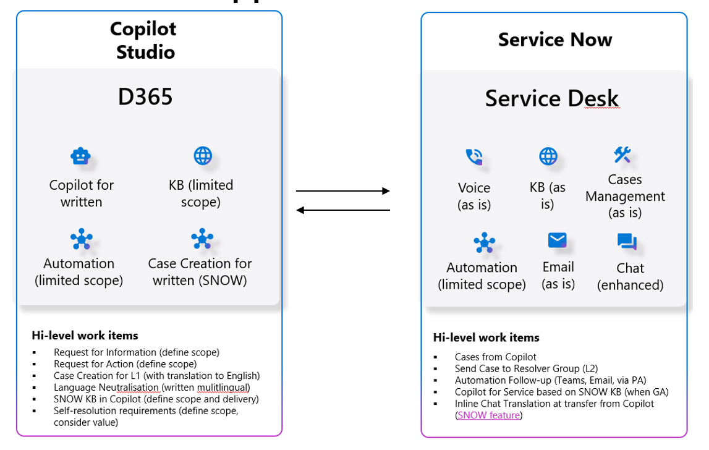

* **Out of Box Standard Deployment**
* **Shall Include OOB functions as per the available SKU of D365 Customer Service.**
* **Standard workflow configurations.**
* **5 reports on Power BI Included in OOB deployments.**

**The following shall be the part of Phase 2a, with a separate commercial arrangement.**

* **Data Migration / Integration / Automation.(Phase 2a)**

**Timelines and Schedule:**

**The project shall be delivered as per the following proposed schedule.**

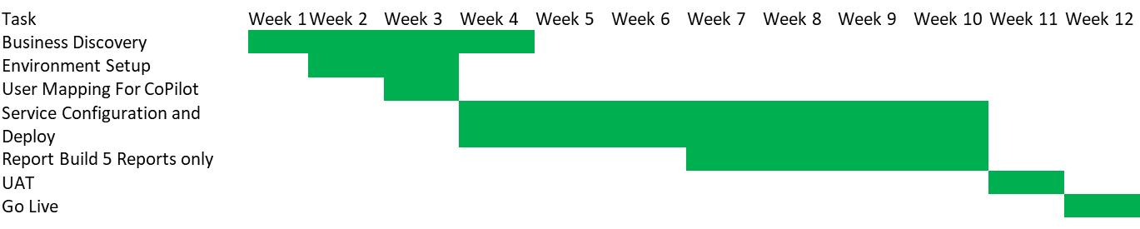

**Resource Deployment:**

The following shall be the resource deployment plan for the OOB functions configurations and business discovery:

|  |  |  |  |
| --- | --- | --- | --- |
| Skill | Level | Allocation | Duration |
| Functional Analyst | 5 Plus Years | 100% | 4 Months |
| Techno Functional | 5 Plus Years | 100% | 3 Months |
| Technical | 3 Plus Years | 100% | 3 Months |
| Architect | 15 Plus Years | 25% | 1 Month |
| .net for Integrations | 3 Plus Years | TBD | |
| Power BI | 3 Plus Years | 100% | 1 Month |
| Power Apps | 3 Plus Years | 100% | 2 Months |
| Program Manager | 15 Plus Years | 25% | 1 Month |

**Pre-requisite:**

The following would be the prerequisite for the proposed project:

